**Introduction**

**About EEG & how to explain it to a student**

Your brain is made up of billions of nerve cells, and they’re connected to each other in networks. Every time you make a movement or have an emotional response, your brain also experiences lots of activity - it’s firing messages across networks to say “our human is now moving his left arm” or “our human is now blinking”.

These actions can be recorded in the form of graphs, just like you can record your heartbeat on a graph and see it on a heartbeat monitor. Brain wave graphs are recorded using EEG, which stands for Electroencephalography. Your brain emits different types of waves depending on your state - whether you’re awake or asleep, relaxed or distressed. Based on these emotions and actions, the graphs will record different patterns and different types of waves.

One second of EEG signal:

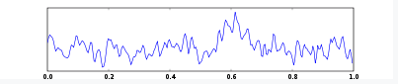

Signals for different states: 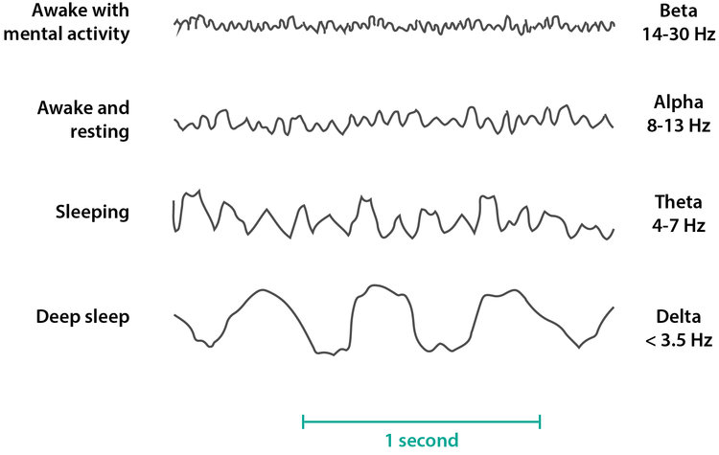

**About the Muse headband & its technology**

The Muse headband is an easy way for us to record our EEG data. The headband is used to detect and measure the activity of your brain, and it uses 7 finely calibrated sensors to do so. There’s 2 sensors on the forehead, 2 behind the ears, and 3 additional reference sensors in the middle of your forehead.

Diagram:

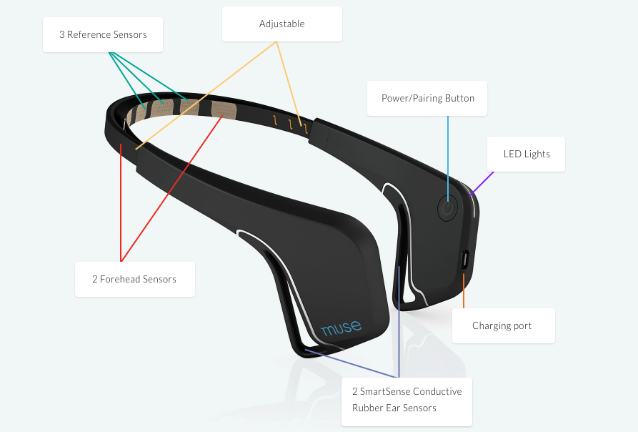

The headband starts by calibrating, which means the headband records your brain waves for a few seconds when you’re in a resting, calm state. This sets an example for what “relaxed” looks like for your brain.

The Muse headband was made so that you can track your brain activity as you meditate - if you finish a meditation session and see that your brain activity wasn’t very calm, it’s a sign that you need to relax more and spend some time really thinking about nothing :)

Example graph from 50 seconds on the Muse app:

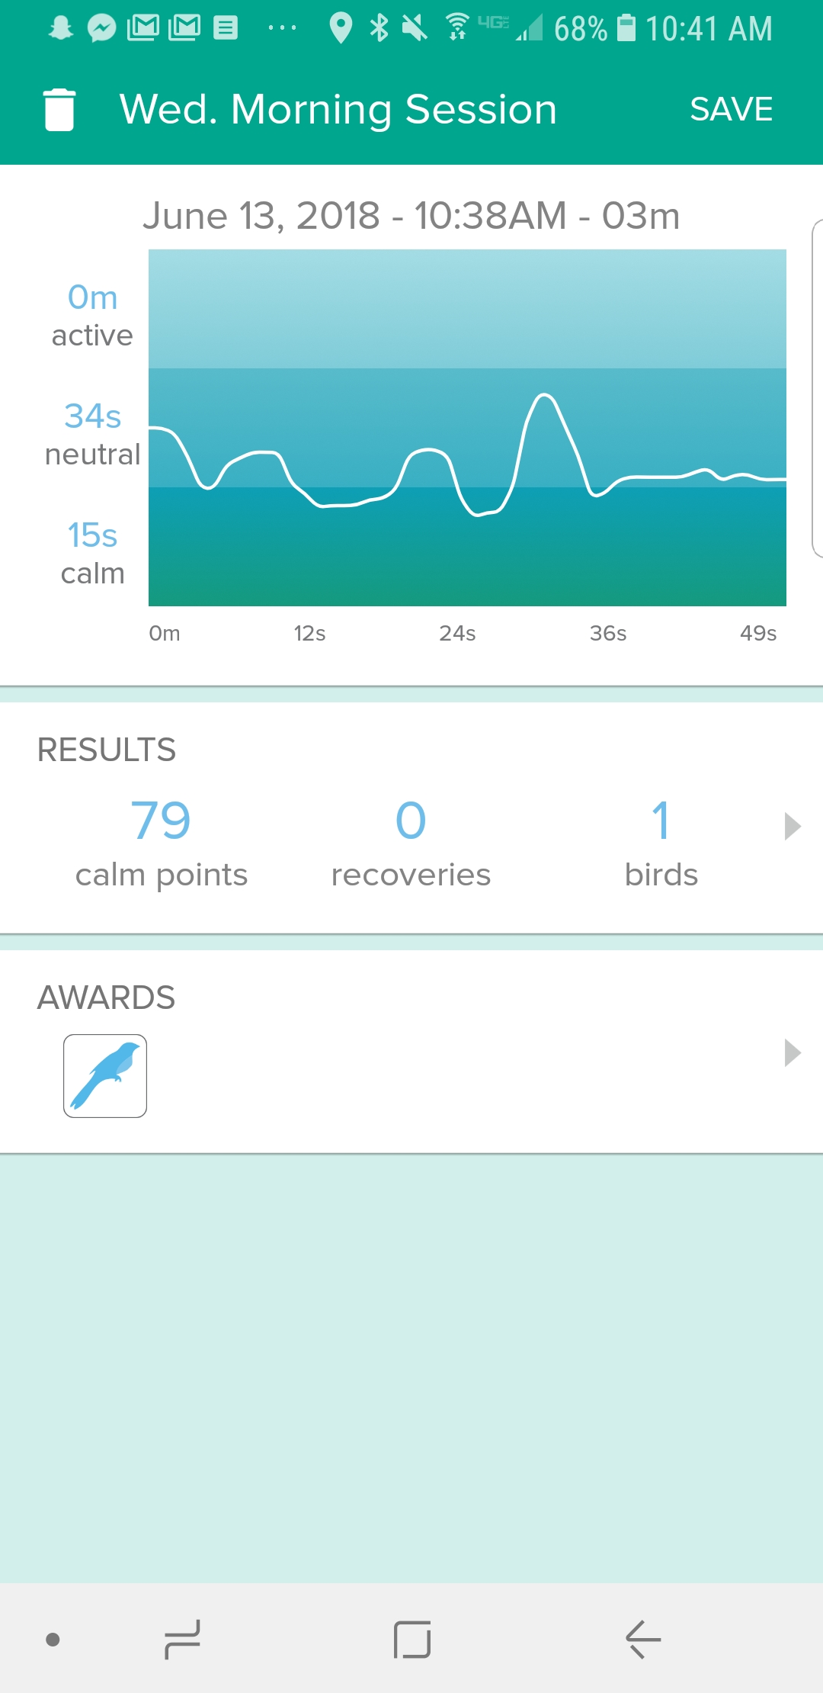

The first bump around 10s was right arm movement, the second bump around 20s was left arm movement, and the last big bump around 30s was a strong blink.

(prompt questions for teachers)

(next activity for students)

Sources:

<https://www.mayoclinic.org/brain/sls-20077047?s=1>

<https://en.wikipedia.org/wiki/Electroencephalography#Wave_patterns>

<http://www.choosemuse.com/what-does-muse-measure/>

<https://medium.com/@urish/reactive-brain-waves-af07864bb7d4>